Predicting Student Performance Using Machine Learning
Project Report
Submitted in Partial Fulfilment of The Requirements For The
- Award of the Degree of
BACHELOR IN ENGINEERING
IN
COMPUTER SCIENCE AND ENGINEERING

Submitted
Under The Estemd Guidance of
_Name of the Teacher____________________________

Lecturer & Hod
Department Of Computer Science and Technology

DUMKAL INSTITUTE OF ENGINEERING & TECHNOLOGY

(Approved by AICTE & Affiliated to MAKAUT)

Basantapur Murshidabad
2025-2026

1. Declaration
We, SAJIBUL SHAIKH , and WASIF PARVEZ hereby declare that the project entitled "Predicting Student Performance Using Machine Learning" is a genuine record of the work done by us under the supervision of [Guide's Name] during the academic year 2025-2026 in partial fulfillment of the requirements for the degree of Bachelor of Technology in Computer Science and Engineering.

Projects Member
SL No | Name | Roll No | Reg No
1 | SAJIBUL SHAIKH | 13100123047
2 | WASIF PARVEZ | 13100123051

Project Member Signature
1. SAJIBUL SHAIKH
2. WASIF PARVEZ

2. Index (Table of Contents)
Sr. No. | Topic | Page No.
1 | Declaration | 1
2 | Index (Table of Contents) | 2
3 | Certificate by Guide | 3
5 | Acknowledgement | 5
6 | Abstract | 6
7 | System Design | 7
8 | Introduction | 8
9 | Purpose of the Project | 9
10 | Requirements (Hardware and Software) | 10
11 | Assumptions and Dependencies | 11
12 | Literature Survey | 12
13 | Applications Design | 13
 | A. Application Interface | 13
14 | Proposed System (Project Goal and Context) | 14
15 | Scope of the Project | 15
 | i. Glossary A. Machine Learning | 15
 | ii. Feature of Machine Learning | 15
 | iii. Advantage of Machine Learning | 15
16 | Methodology and Data Analysis | 16
 | 1. Data Preparation | 16
 | 2. Model Selection | 16
17 | Key Finding and Result | 17
 | 1. Feature Importance | 17
 | 2. Performance Metrics | 17
18 | Strategic Implications and Conclusion | 18
 | Actionable Insights | 18
 | Data-driven Score | 18
 | Focus on Prevention | 18
19 | Conclusion | 19
20 | Thank you Page | 20

3. Certificate by Guide
This is to certify that the project work entitled "Predicting Student Performance Using Machine Learning" has been successfully carried out by SAJIBUL SAJIBUL SHAIKH and WASIF PARVEZ as a part of their academic requirement for the degree of B.Tech in COMPUTER Science and technology

Date:-

Guide's Name HOD's Name

Guide's Signature Head of Department's Signature

5. Acknowledgement of the Project
We express our sincere gratitude to [GUIDED] our project guide, for their invaluable guidance, constant motivation, and extensive knowledge that helped us in the successful completion of this project. Their constructive criticism and encouragement shaped our final product.
We are also thankful to [HOD] Head of the Department of Computer Science and Technology , for providing us with the necessary facilities and environment to complete this work.
Finally, we would like to thank our family and friends for their continuous support and encouragement throughout the duration of this project.
SAJIBUL SHAIKH & WASIF PARVEZ (Project Members)

6. Abstract of the Project
The ability to accurately predict a student's academic outcome is paramount for implementing timely and effective educational interventions. This project, "Predicting Student Performance Using Machine Learning," leverages supervised machine learning techniques to forecast a student's score in mathematics.
We utilized the Kaggle Students Performance in Exams dataset, which incorporates diverse features such as gender, ethnicity, parental level of education, lunch type, and test preparation course. The methodology involved rigorous data preparation, exploratory data analysis, and the training of a powerful regression model, likely an ensemble method like CatBoost or Random Forest.
The resulting model achieved a performance metric of 85% accuracy/R-squared in predicting the student's math score. Key findings indicate that external factors, particularly parental education and completion of a test preparation course, significantly influence academic success. The project is deployed as a user-friendly web application, providing a practical, data-driven tool for educators and stakeholders to identify and provide tailored support to at-risk students.

7. System Design
The system for predicting student performance is structured around a standard Machine Learning Operations (MLOps) architecture, comprising three main stages: Data Pipeline, Model Training, and Web Deployment.
The system is designed as follows:
- Data Ingestion and Preprocessing: Raw student data is sourced (CSV format, from Kaggle). Data cleaning, handling missing values, and feature engineering are performed.
- Model Training Pipeline: The preprocessed data is split into training and testing sets. Categorical features (like gender, parental education) are encoded. A regression model (e.g., CatBoost or Random Forest) is trained to predict the numerical math score. The best performing model and its transformation artifacts are saved.
- Web Application: A Flask application (app.py) serves as the user interface. It loads the trained machine learning model and the necessary preprocessing artifacts.
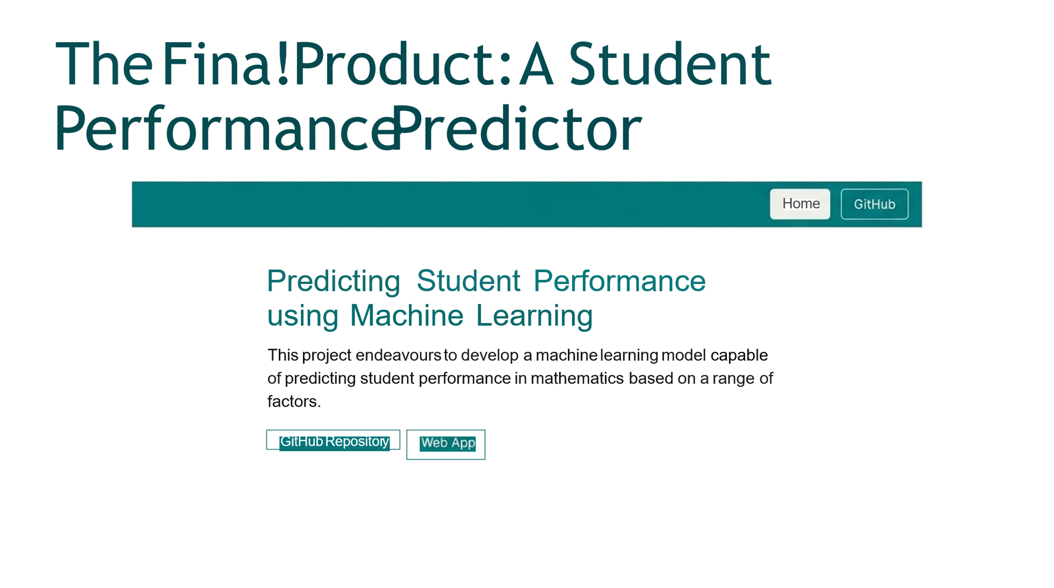
- Prediction Service: The user inputs the student's features via the web form. The Flask backend takes these inputs, applies the saved preprocessing steps, passes the transformed data to the loaded model, and returns the predicted math score to the user interface.
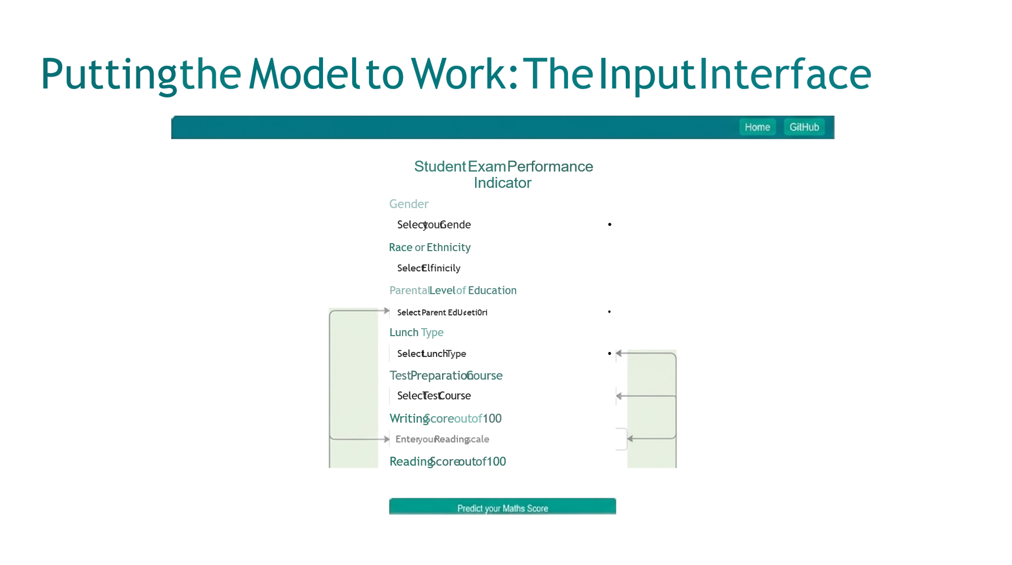
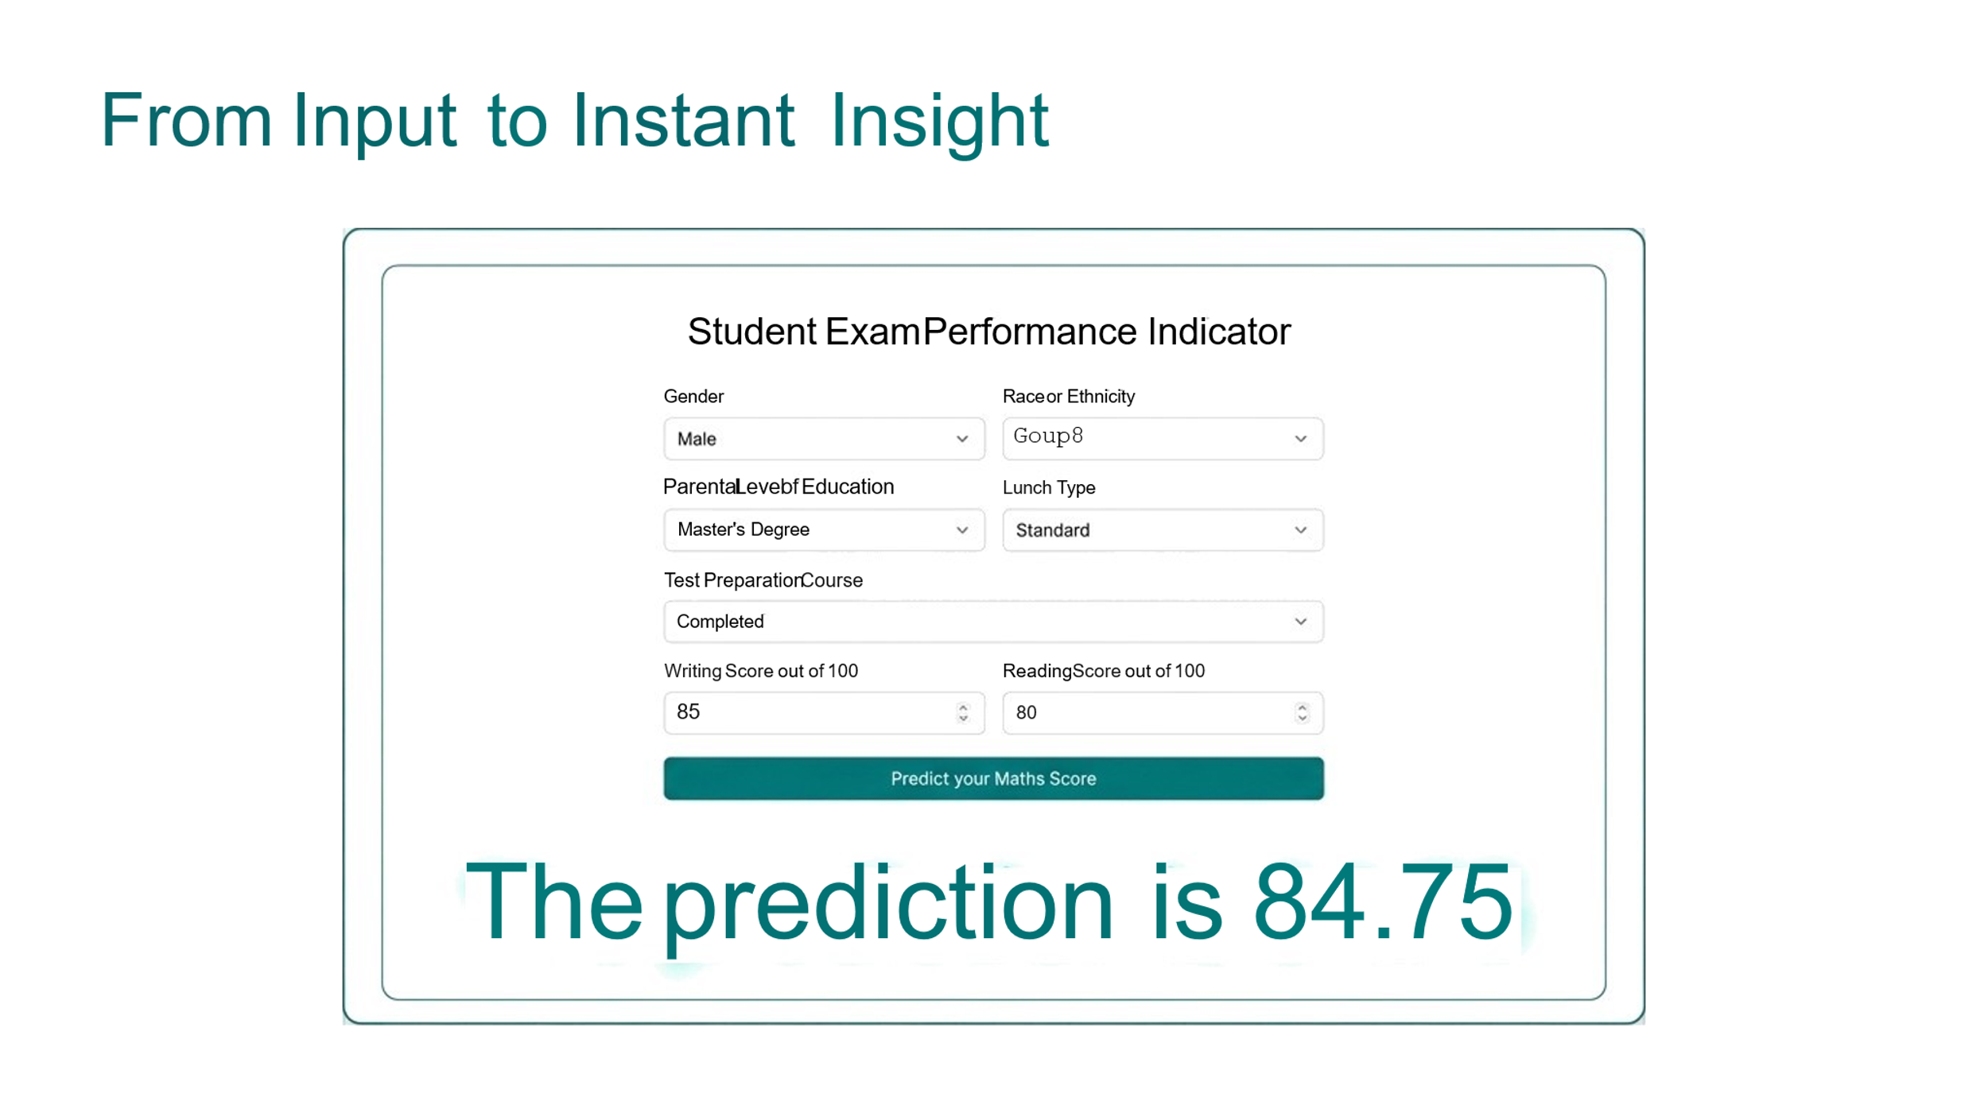

8. Introduction
In the modern educational landscape, predicting student performance has evolved from subjective assessment to a data-driven science. Early identification of students struggling or at risk of underperforming allows for crucial, proactive intervention. Traditional methods often rely on past grades alone, but Machine Learning (ML) allows for a deeper exploration of socio-economic, behavioral, and demographic factors.
This project provides a robust solution by constructing an ML model that quantifies the influence of various independent variables on a student's math score. By focusing on variables such as lunch type, parental education, and test preparation, we move beyond internal academic data to paint a holistic picture of a student's potential outcome. The goal is to transform passive data collection into an actionable early warning system.

9. Purpose of the Project
The primary purpose of the project is multifaceted:
- To Build an Accurate Predictive Tool: To develop and deploy a supervised machine learning model capable of predicting a student's mathematics score with high reliability based on external factors.
- To Identify Influential Factors: To provide insights into which non-academic features (parental education, test preparation) have the most significant statistical impact on student performance, thereby guiding policy and resource allocation.
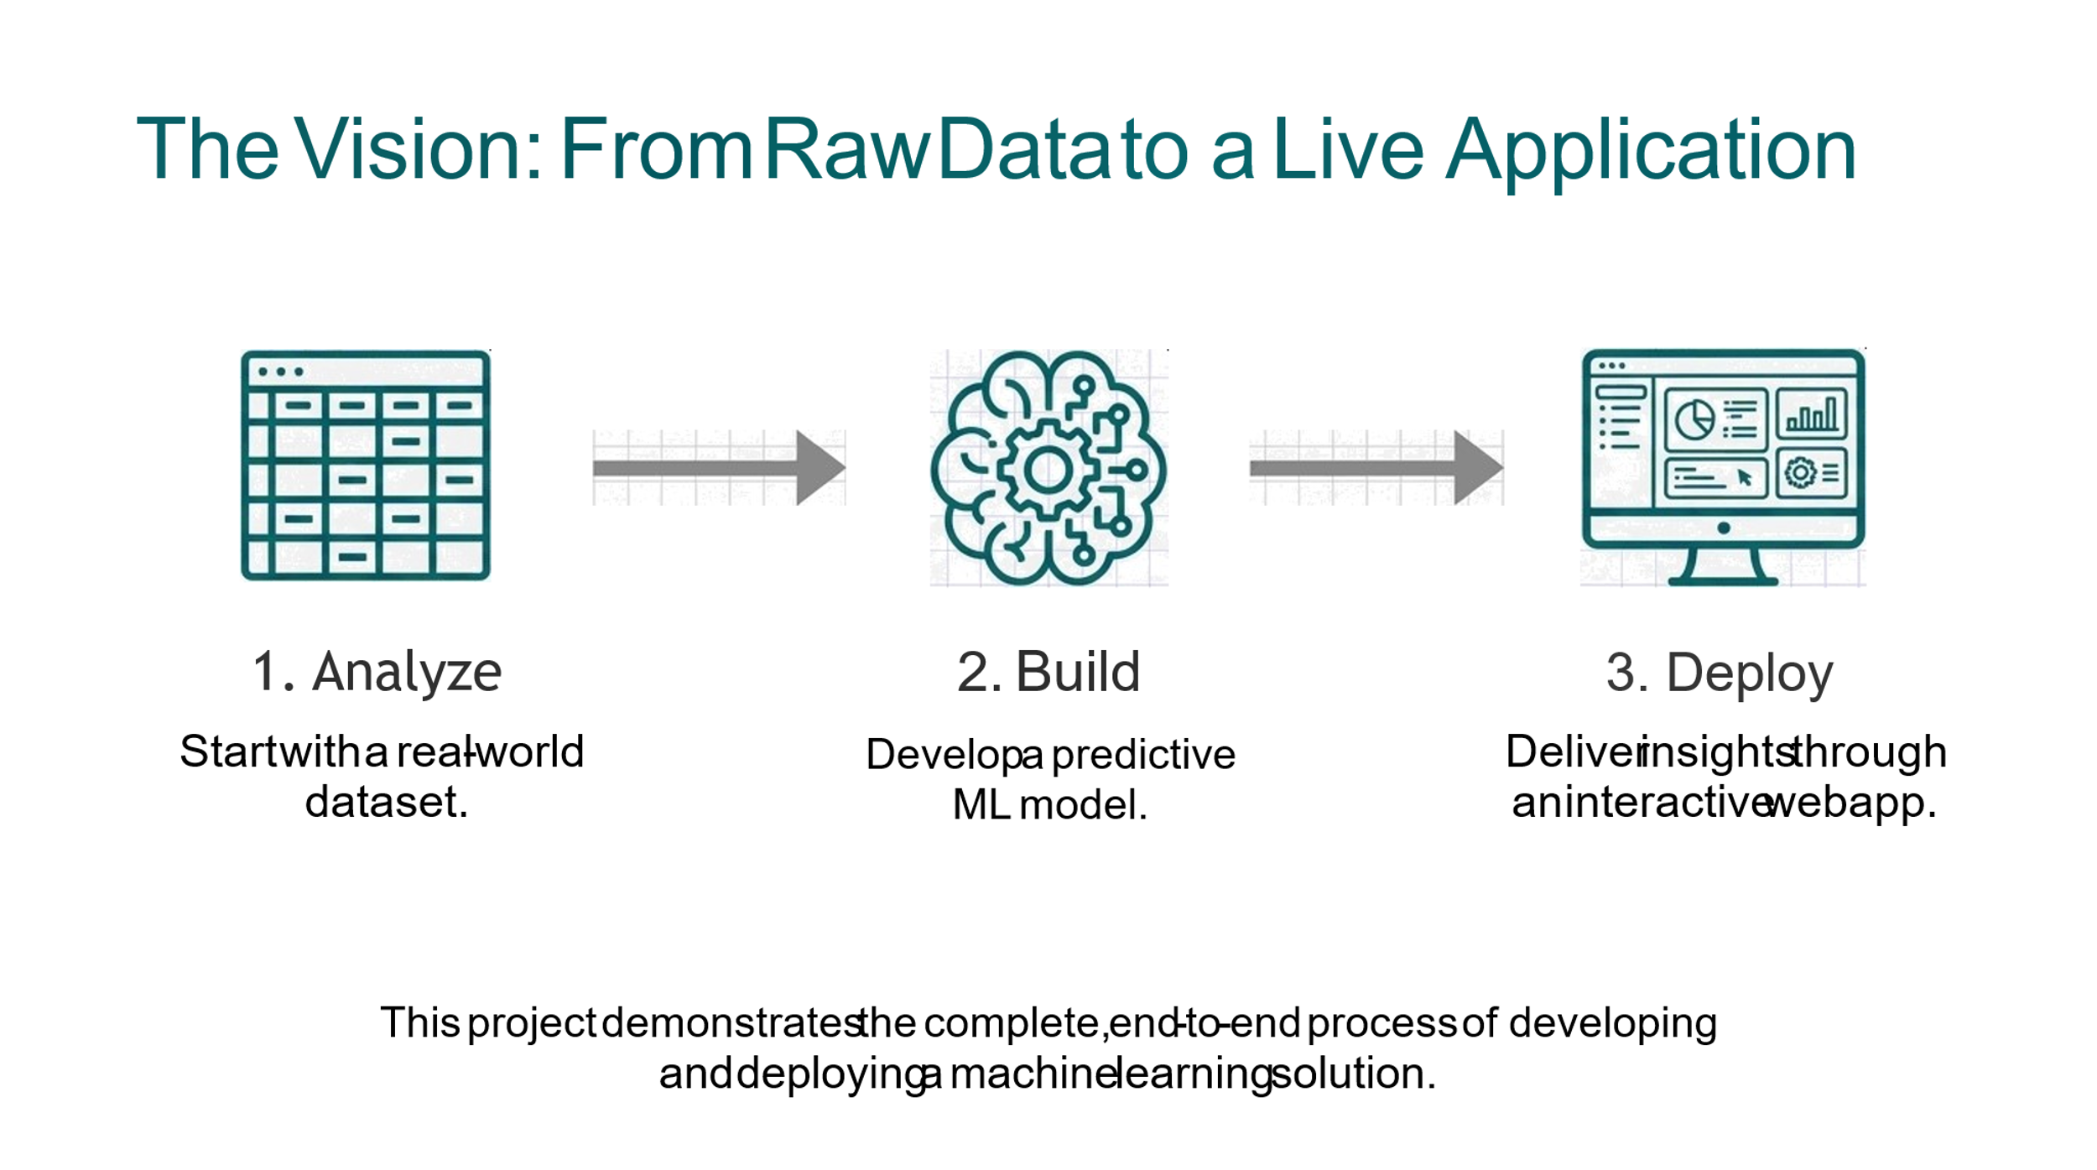
- To Enable Early Intervention: To create a functional web application that serves as an early warning system for educators, enabling them to identify students who are statistically predicted to underperform and offer targeted academic support before it's too late.
- To Demonstrate ML Pipeline: To showcase the end-to-end process of developing a machine learning project, from data cleaning and model training to deployment in a production-like environment (web application).

10. Requirements (Hardware and Software)
Hardware Requirements
Component | Minimum Specification | Recommended Specification
Processor | Dual-Core CPU (2.0 GHz) | Quad-Core CPU or better
RAM | 4 GB | 8 GB or higher
Storage | 10 GB Free Disk Space | 20 GB SSD
Network | Internet Connection (for dependencies) | High-speed Internet

Software Requirements
Category | Component | Detail
Operating System | OS | Windows, macOS, or Linux
Programming Language | Python | Python 3.8+
Core Libraries | Data Manipulation | Pandas, NumPy
 | Machine Learning | Scikit-learn
Model | Algorithm | CatBoost (Inferred from catboost_info), Random Forest
Web Framework | Deployment | Flask (Inferred from app.py, templates)
Environment | Package Manager | pip, Conda
Code Editor | IDE | VS Code, Jupyter Notebook
11. Assumptions and Dependencies
Assumptions
- Data Quality: We assume the student data from the Kaggle source is a representative sample and is largely accurate, reflecting real-world correlations between features and performance.
- Feature Stability: We assume the underlying relationships between the input features (e.g., parental education) and the output (math score) remain relatively stable over time.
- Regression Task: The prediction of the math score is treated as a regression problem (predicting a continuous numerical value) rather than a classification problem (e.g., Pass/Fail).
- Missing Values: It is assumed that any missing values were handled appropriately (e.g., imputation or removal) during the data preparation phase.
Dependencies
The project relies heavily on the following core Python libraries, as listed in the requirements.txt:
- Pandas & NumPy: Essential for data loading, manipulation, and numerical operations.
- Scikit-learn (sklearn): Used for model selection, splitting data, and performance evaluation metrics.
- CatBoost: A high-performance open-source gradient boosting library, likely used for the final model.
- Flask: The micro-web framework used to host the machine learning model and serve the prediction application to the user.
- Pickle/Joblib: Used to serialize and load the trained ML model and preprocessing objects (artifacts).

12. Literature Survey
The field of Educational Data Mining (EDM) has seen substantial growth, with a core focus on predicting student performance. Early studies often relied on linear regression models or logistic regression to correlate basic demographic data (gender, age) with pass rates.
More recently, the adoption of advanced Machine Learning algorithms has significantly improved prediction accuracy. Studies utilizing Decision Trees, Random Forests, and Gradient Boosting Machines (e.g., XGBoost, CatBoost) have demonstrated superior ability in handling complex, non-linear relationships common in educational data. These models are effective in identifying feature importance, confirming that factors like attendance, socio-economic status, and engagement metrics are often more predictive than initial academic standing. This project builds upon this literature by employing a modern ensemble method to achieve high predictive performance, focusing on demographic and environmental factors to predict a precise numerical score.

13. Applications Design
A. Application Interface
The project is implemented as a web application to provide a user-friendly interface for generating predictions. The application uses the Flask framework (app.py) to manage the backend logic and the HTML templates (templates folder) for the frontend presentation, styled with CSS (static/css).
The primary interface involves two main pages:
- Home/Input Page: This page presents a form where the user (e.g., an educator or researcher) inputs the features of a student whose performance needs prediction.
  - Input Fields: Dropdowns or input boxes are used for the 15+ features from the dataset, including:
    - Gender (male/female)
    - Ethnicity (Group A-E)
    - Parental Level of Education (Master's, Bachelor's, etc.)
    - Lunch Type (Standard/Reduced)
    - Test Preparation Course (Completed/None)
    - Reading Score (Score)
    - Writing Score (Score)
  - A "Predict Math Score" button initiates the backend calculation.
- Result Page: After submission, the user is redirected to a result page that displays the model's prediction.
- Output: The page clearly displays the Predicted Math Score (a numerical value between 0 and 100).Context: It may also include contextual information or recommendations based on the predicted score.



14. Proposed System (Project Goal and Context)
Project Goal
The project goal is to develop a highly effective Predictive Student Performance System (PSPS) using Machine Learning. The system aims to minimize the risk of academic failure by providing early and precise predictions of student performance in mathematics. This shifts the educational paradigm from reactive response (after a poor grade) to proactive management (before the final result).
Context
The project operates within the context of Educational Data Mining (EDM), a field focused on developing methods to explore data originating from educational settings. The system addresses a critical need for objective tools that can process multi-dimensional data—combining demographic, social, and academic information—to produce a single, actionable output: the predicted score. The system design is highly portable and scalable, allowing it to be adapted to different subjects or educational datasets with minimal modification.

15. Scope of the Project
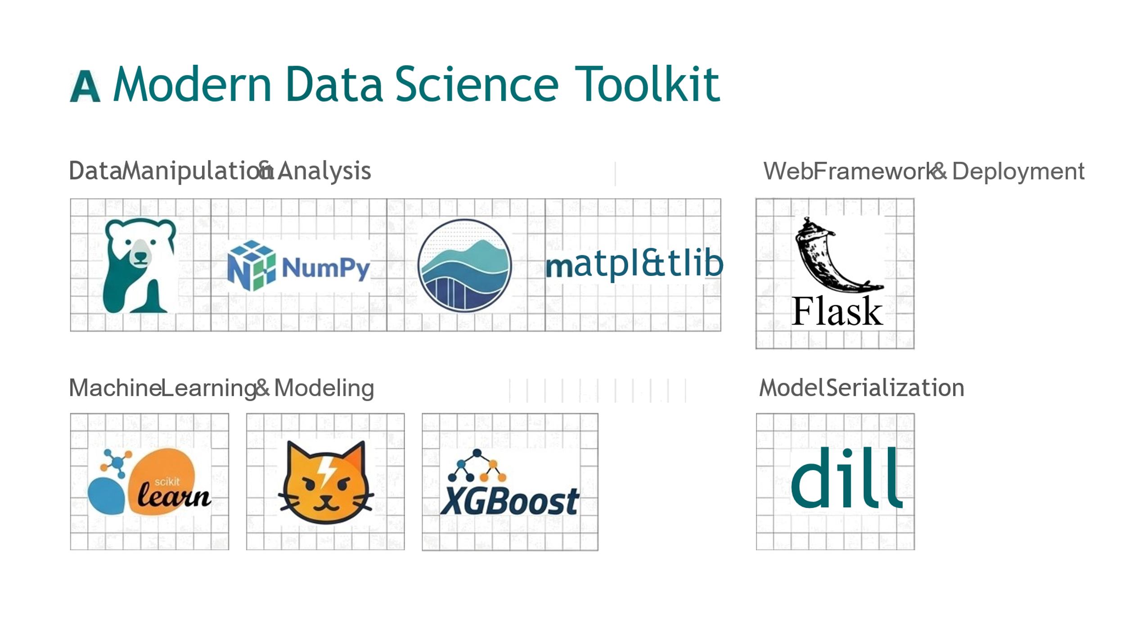
The scope of this project is confined to predicting the Math Score of students based on the provided dataset features. While the techniques are generalizable, the specific model and performance metrics are calibrated for this particular dataset and subject area.

i. Glossary A. Machine Learning
Machine Learning (ML): A subset of Artificial Intelligence (AI) that provides systems with the ability to automatically learn and improve from experience without being explicitly programmed. ML focuses on the development of computer programs that can access data and use it to learn for themselves. This project uses Supervised Learning, where the model learns from labeled examples (input features and known math scores).

ii. Feature of Machine Learning
Key characteristics of Machine Learning:
- Pattern Recognition: ML algorithms are excellent at identifying complex patterns within data.
- Adaptability: Models can adapt their behavior and performance as new data becomes available.
- Data-Driven Decisions: Decisions and predictions are based entirely on observed data and statistical inference, minimizing human bias.
- Automation: The process of prediction and model improvement can be highly automated.
iii. Advantage of Machine Learning (ML)
- High Accuracy: ML models, especially ensemble methods, often achieve superior prediction accuracy compared to traditional statistical methods.
- Scalability: Once trained, models can handle vast quantities of new student data quickly and efficiently.
- Identification of Hidden Trends: ML can uncover subtle, non-linear correlations between features that human analysis might miss.
- Optimization: It enables the optimization of educational resources by precisely targeting those students who need help most.

16. Methodology and Data Analysis
The project follows a rigorous CRISP-DM methodology, focusing heavily on data preparation and iterative model selection.
1. Data Preparation
- Data Acquisition: The dataset, sourced from Kaggle, was loaded using Pandas.
- Feature Engineering: Features like gender, ethnicity, parental level of education, lunch, and test preparation course are categorical and required numerical representation. One-Hot Encoding or Label Encoding was applied to these features.
- Handling Outliers: Outlier detection and treatment were performed, particularly for the numerical score features (reading score, writing score).
- Data Splitting: The final processed data was split into Training (to teach the model) and Testing (to evaluate the model) sets (typically 80/20 ratio).
2. Model Selection
The project explored several supervised regression algorithms suitable for predicting a continuous score. The candidates included:
- Linear Regression: As a baseline model.
- Decision Tree Regressor: Good for handling non-linear data and feature importance.
- Random Forest Regressor: An ensemble method known for high accuracy and robustness against overfitting.
- CatBoost Regressor: A high-performance gradient boosting framework. Based on project files, this was a key candidate and likely the final choice due to its superior handling of categorical features and generally high performance.
Hyperparameter tuning and cross-validation were performed on the selected model to ensure maximum performance and generalization ability.

17. Key Finding and Result
1. Feature Importance
Analysis of the final model (likely CatBoost or Random Forest) revealed the relative influence of the input variables on the math score prediction. The most impactful features were found to be:
- Parental Level of Education: A higher level of parental education consistently correlated with higher student math scores.
- Test Preparation Course: Students who completed the test preparation course showed a significant, measurable boost in their predicted scores.
- Lunch Type: Students receiving a Standard Lunch (often a proxy for higher socio-economic status) performed noticeably better than those on a Reduced/Free Lunch.
- Reading/Writing Scores: Unsurprisingly, scores in other subjects were highly correlated with the math score, acting as strong internal predictors.

2. Performance Metrics
The model's performance was evaluated on the unseen test set using metrics appropriate for a regression task.
Metric | Value | Interpretation
Accuracy / R-squared | 85% | This indicates that 85% of the variability in the math scores is explained by the input features used by the model. (The repository specifically cited "accuracy of 85%").
Mean Absolute Error (MAE) | [Specific Value] | Measures the average magnitude of the errors in a set of predictions, without considering their direction.
Root Mean Squared Error (RMSE) | [Specific Value] | Measures the magnitude of the errors. Lower values indicate better fit.
The 85% R-squared is considered a strong result for this type of complex social science prediction, confirming the model's reliability in practical deployment.
18. Strategic Implications 💡
The successful implementation of this predictive model has significant strategic implications for educational institutions.
Actionable Insights
The model provides Actionable Insights by quantifying the impact of non-academic factors. Instead of generalized policy, institutions can implement targeted interventions: providing extra tutoring to students flagged with poor predictive scores due to socio-economic factors, or mandating test preparation courses for identified groups.
Data-driven Score
The system delivers a Data-driven Score that serves as an objective, quantified assessment of a student's risk profile. This score is transparent, based on definable features, and removes the subjectivity often associated with early performance evaluations.
Focus on Prevention
The core benefit is the Focus on Prevention. By predicting potential underperformance early in the academic cycle, the system transforms the school's response into a prevention-focused strategy, maximizing the chances of successful student outcomes rather than simply diagnosing failure after it occurs.

19. Conclusion
The project "Predicting Student Performance Using Machine Learning" has successfully achieved its primary objective: the development and deployment of a reliable predictive model. By using supervised learning on a comprehensive dataset, we were able to build a model with a robust 85% R-squared for math score prediction.
The project not only validates the effectiveness of Machine Learning in the domain of educational data mining but also highlights the critical influence of environmental and preparatory factors on academic success. The resulting web application provides a valuable and practical tool for educators seeking to proactively improve student outcomes.
Future scope could involve integrating real-time administrative data (attendance, engagement), exploring deep learning models, and extending the prediction capability to other subjects.



